[Intermediate Workshop III: Algorithmic Trading with R and IBrokers API](http://www.meetup.com/New-York-Big-Data-Workshop/events/193392112/)

First download TWS Standalone from [www.interactivebrokers.com](http://www.interactivebrokers.com)

<https://www.interactivebrokers.com/en/index.php?f=552>

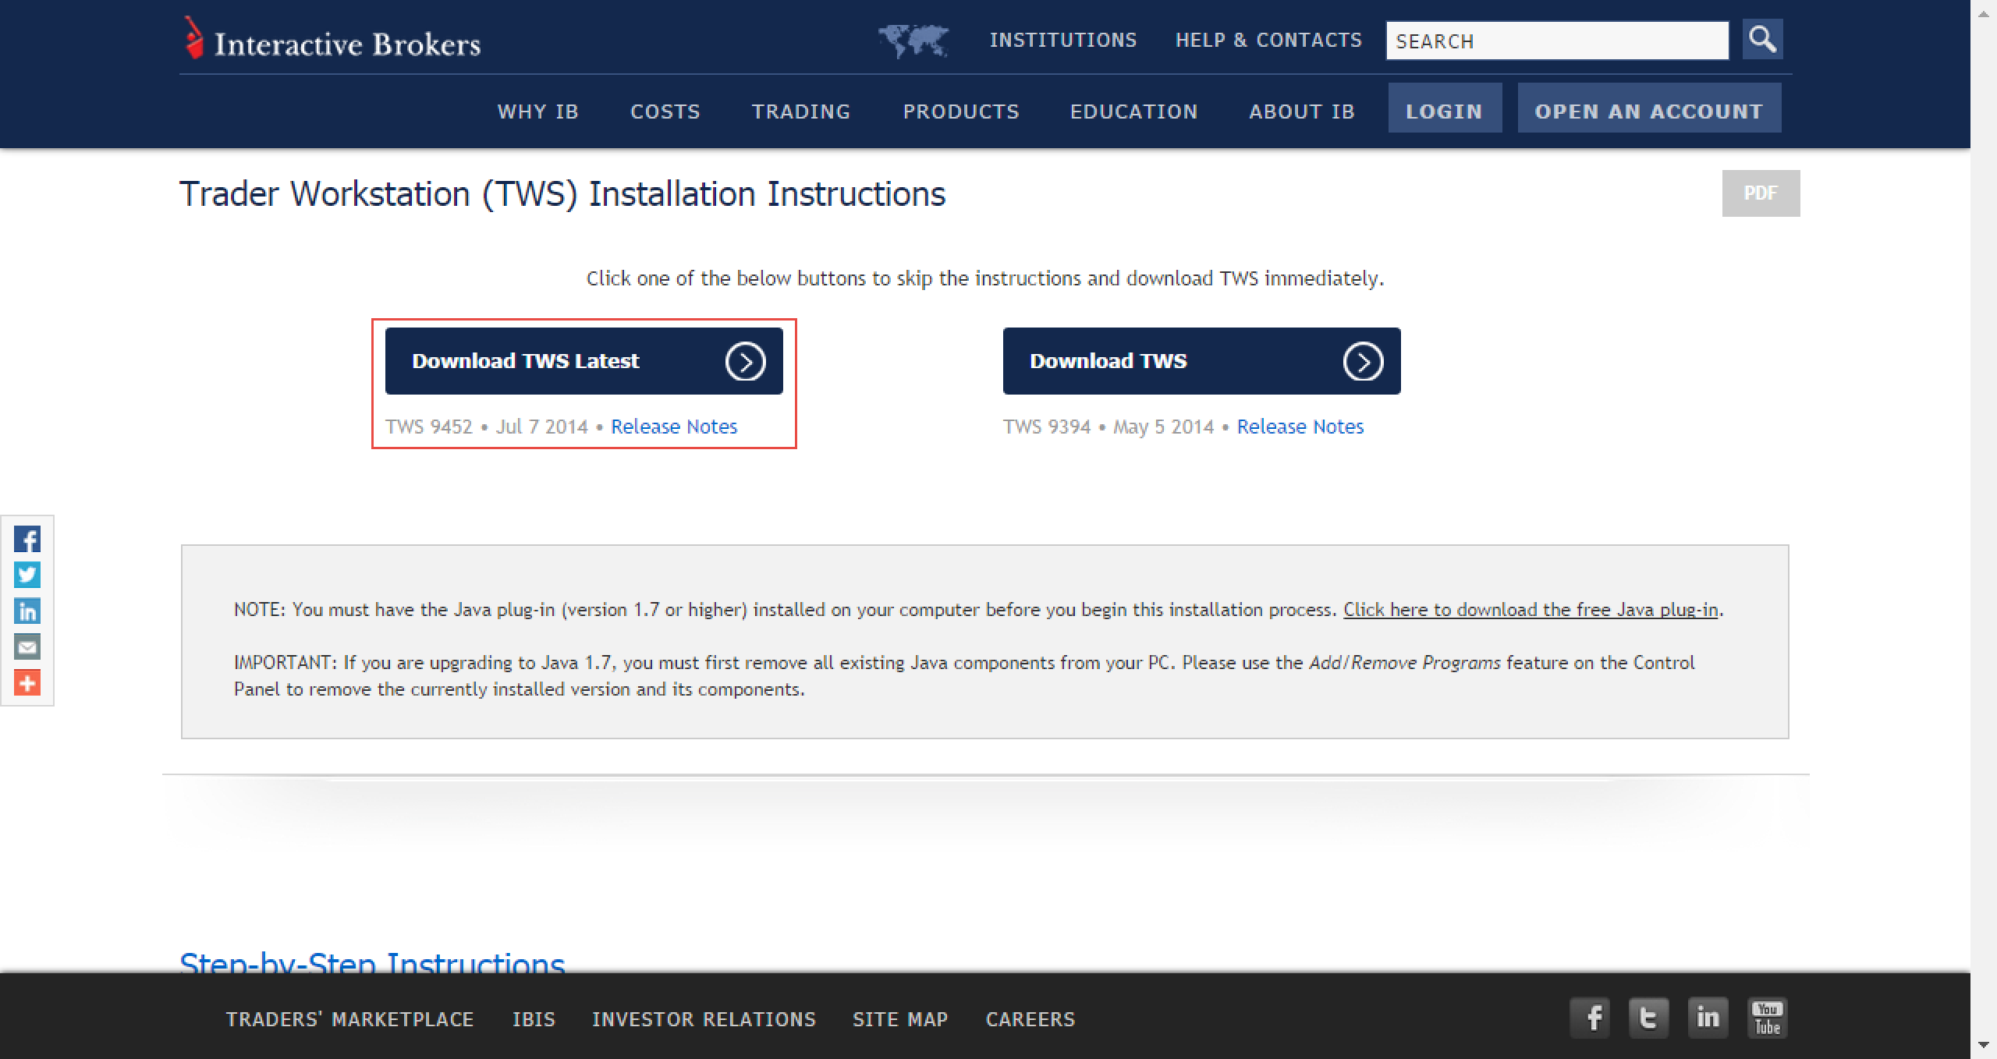

Download TWS Latest and install it.

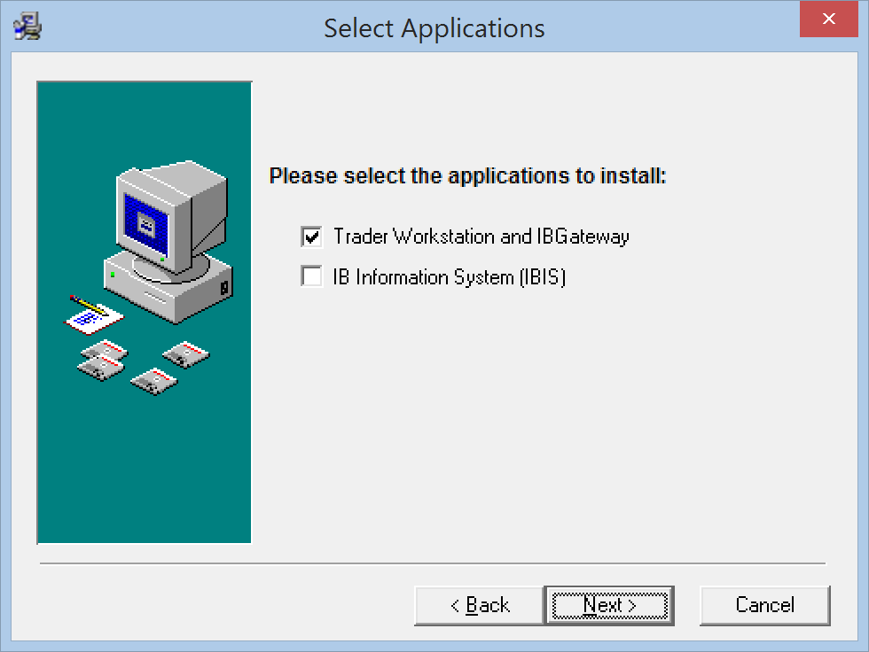

Run Trader Workstation 4.0

Login and leave running

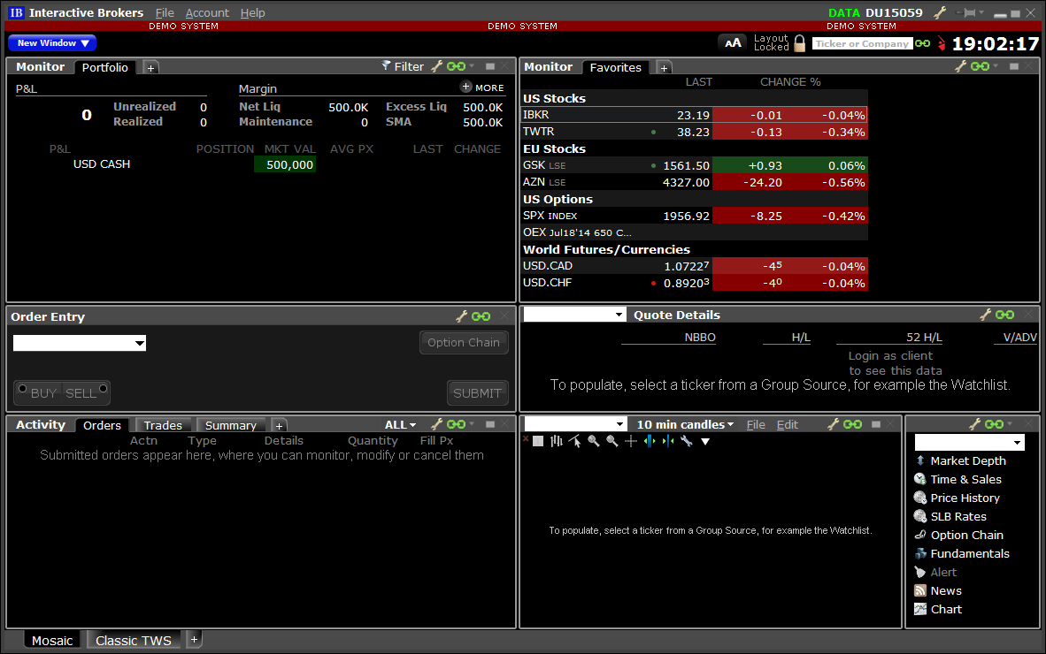

Set up Settings:

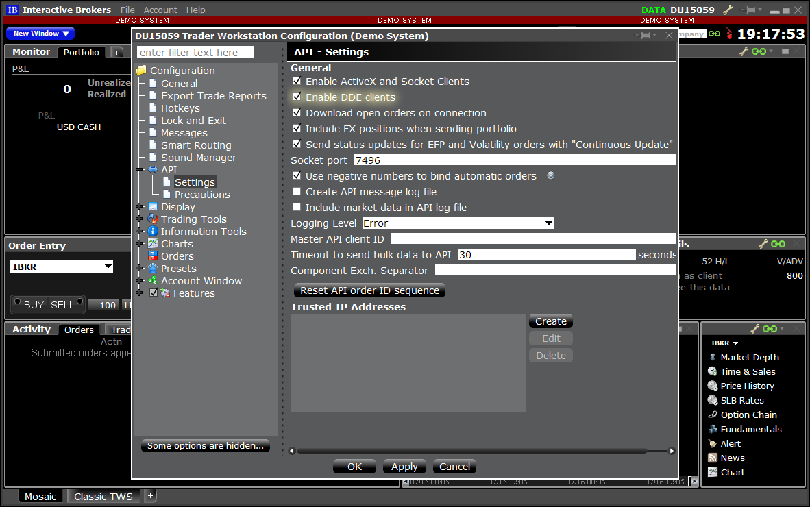

In R:

tws <- twsConnect()

Select Yes in the popup:

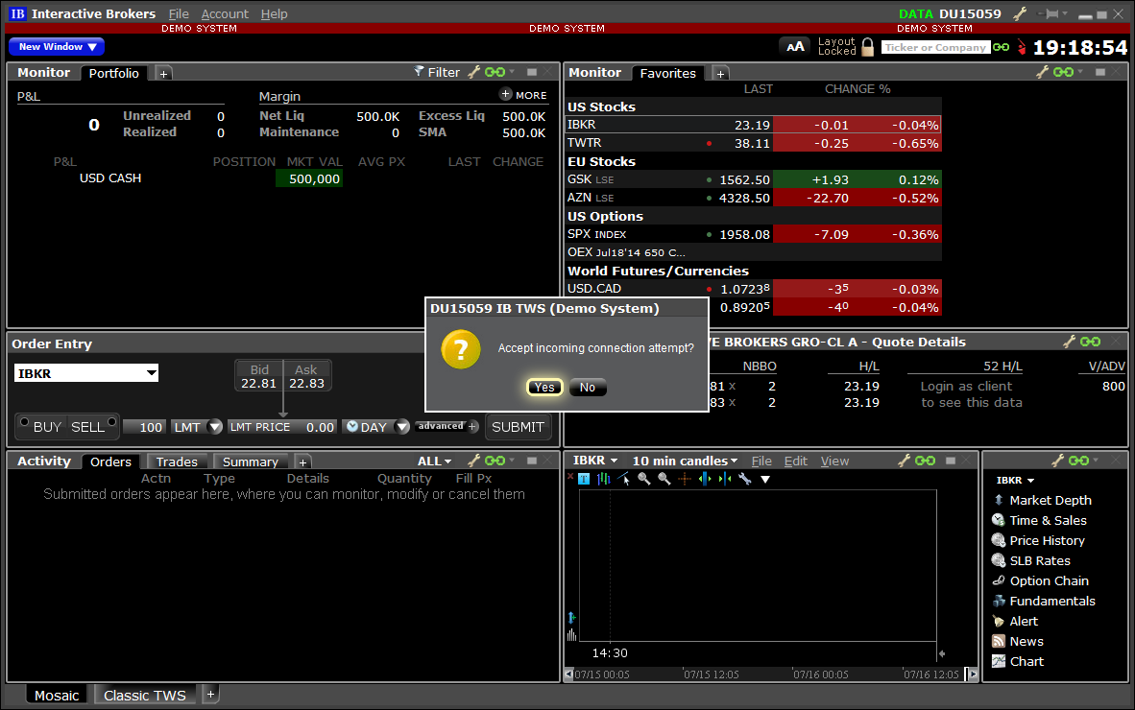

## Let’s try it out!

Next, we can see how IBrokers package works.

In R:

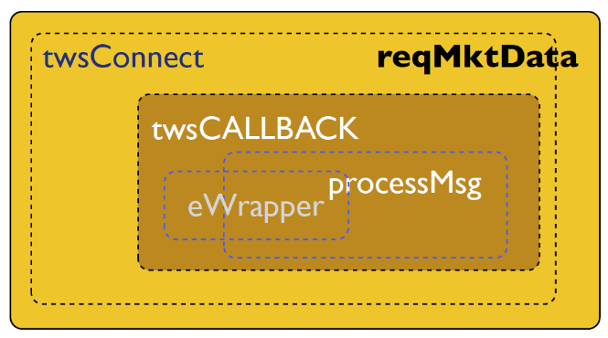> reqMktData

*Request market data*

> twsCALLBACK

*Internal main loop*

> processMsg

*Process each message separately*

> eWrapper

*Built in callback methods*

